**Kings For Kings**

**BORIS MERLO, MICHAEL NOSEWORTHY, MADALYN KENDRICK, MATTHEW HOLZAPFEL**

**borismerlo@gmail.com**

**mikethenose@gmail.com**

**madalynkendrick@gmail.com**

[**meholzapfel@gmail.com**](mailto:meholzapfel@gmail.com)

Game Design Document

Draft 1.0.0

Presenting:

**LEARN OR STARVE**

• High level description of our game

Our goal for this game is to teach the players with new/wide range of language vocabulary by using repetition, while at the same time implementing a fun story. Audience will be for all ages, we want this to be a learning experience for all. The repetition aspect of our game will help give our players a sense of anticipation and add a bit more challenge to the game’s play style. With this, we believe it will help the player remember more keywords they find, the more they play the game. However, unlike most games that has a multiple lives algorithm, if you choose the incorrect answer once, it’s game over and you’ll have to start over again. An example of this is “The Impossible Quiz”. While that game does come with multiple lives for the players, it’s a fine example of repetition for our game. Every new round the player plays the game, they slowly progress further, recalling previous answers they got correct. We want our players to feel that sense of “Hey, I remember that! I learned something!” achievement.

• UI Flow diagram of how the screens connect to one another

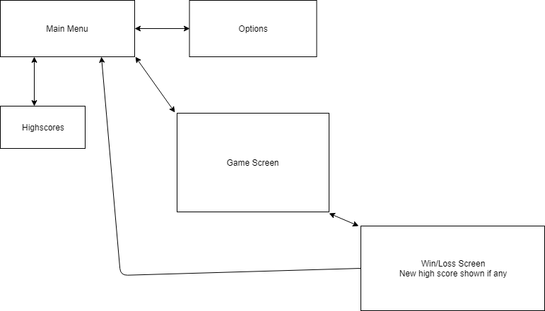

• Rough Layout of all our screens 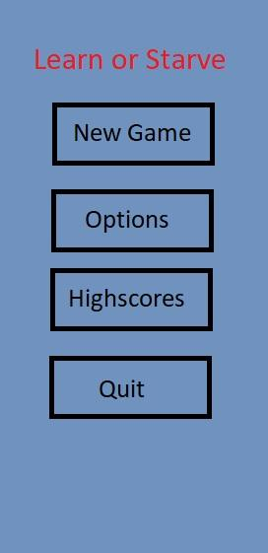 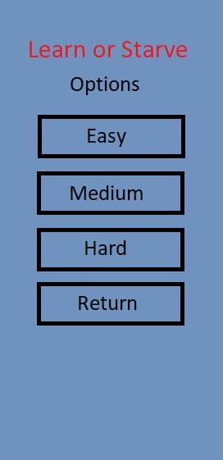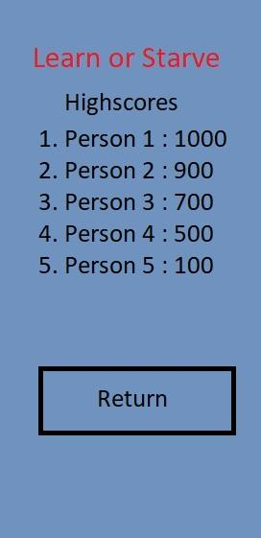 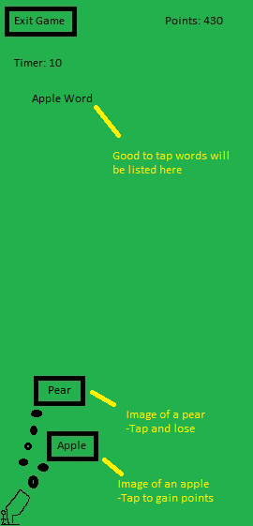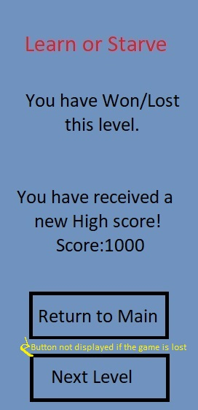

• Backstory of your game

A king decides that to make this kingdom grow, they need to learn a new language in order to extend the horizons to his people. Thus, empowered by a “divine madness”, shoots free food to his people out of cannons from his castle. After he announces what the “food of the hour” is, he will poison the food that is different from the food that the people will pick up. It is up to the player to select the correct piece of food or else risk being poisoned by the king. But the catch is the player has a certain amount of time to eat all the good food. If he fails, the whole village will be at risk of being poisoned and dying at the hands of the king. If the player is successful, the kingdom will prosper for years to come!

• Game mechanics

- Touch screen

- Pop objects on the screen

- The player needs to tap the correct item that is shown on screen

- If the player taps the wrong item they lose

- Enemy objects will be shot out of cannons

- Random items/food

- A word will be revealed at the top of the screen

- The more correct answers you choose, the more words that will appear.

- Timer implementation

- Game speed/time goes faster the more you progress

Targeted platform: Android

Influences: - The Prince by Niccolo Machiavelli

- Worms Armageddon